Growing Up with Music (from Fantasy to Reality)
TBaer aka Barry Fish

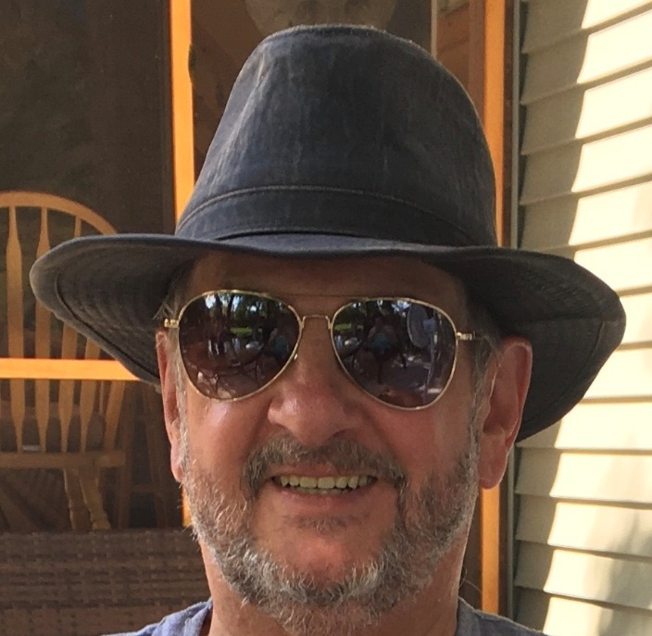
My Music History
I began my music career at the age of 12. I was pretty much into writing free verse poetry early in life. I continue writing today. My music inspiration was The Beatles. They had just arrived in America when I bought my first guitar. My favorite Beatle was Paul McCartney, who played guitar left-handed. As a result, I taught myself to play guitar left-handed even though I am right-handed in everything else I do. I saved up my money from my paper route to buy an actual guitar. No more listening to music and pretending to play on an air guitar for this aspiring musician. Absurdly in retrospect, at that time, I thought all I had to do is strum the guitar strings and music would flow forth in glorious fashion. I very quickly realized that it wasn't going to be at all that easy. I decided that I should probably take lessons. That was a disaster as the instructor was more enamored of his own talents then interested in teaching me.
So, I quit the lessons. I decided that I would buy a book and learn on my own. I remember my first chord book. It was the Mel Bay Book of Chords. After playing for a couple of months and learning some chord progressions, I thought that I would try my hand at singing and playing at the same time. Guess what? Disaster. I couldn't sing and play at the same time. It was a rhythm thing (mental). At that point I was very disillusioned and decided to hang the whole thing up. Two weeks later though, I tried it again and things just fell into place and I've been singing and playing ever since.
When I was 15, my cousin, Bradley Joe Hubert and I used to play together in our basement. Neither of us had much money but at least I had a guitar. Joe played on pots and pans and rather well I might add. He eventually purchased a real drum set and became quite good. He joined a band and although we kept in contact we never played together again. Tragically, he was killed while hitch hiking when he was just 17. I miss him a lot. I know he would have been drumming for some famous band now if he were still alive.
Somewhere between ages 14 and 17, a friend of mine, James Robert Maxa, who was from Chicago, Illinois, came to my small town in Southwestern Minnesota a few times a year with his parents to visit his grandmother. He bought a guitar, and I had mine, so we used to sing and play together, not professionally, but just for fun. I remember that we would play and sing songs by the Mommas and Papa, The Association, Beatles, etc. We would play for his sisters and our families. It was a blast, but I remember so well that when we would start to play for them, that we would look at each other and get the giggles. It took us several takes to get going sometimes, but eventually we would overcome the giggles and play well together. As we got older and after his grandmother died, we saw each other less and less. But I have fond memories that I will cherish forever.
When I was around 17, and while still living at home in Minnesota, I joined my very first band. It was called “Shadow”. It was a five-piece band, and we played a lot of rock n roll and some originals. The members were the amazing Steve Mahlum – Guitar and Vocalist, Lionel Kull - Drummer and Vocalist, Bruce Bernardy - Bass guitar, Dana Viergutz - Vocalist, and me, Guitar and Vocalist. My good friend, Dana and I were in the same grade and so grew up together singing and playing in the school auditorium and the town hall, the Odeon Hall (good echo effects there). We wrote many songs together as we continued to do in Shadow. We often thought of ourselves as Lennon and McCartney (one can dream, ok! ) We had a blast! Unfortunately for us, but good for Dana, he decided to go to college, so the band broke up. Memories abound! Dana and I shared an incredible friendship that I miss.
About a year or two later, I joined a band called “Bandicoot” which later be changed to “Kidd”. The members were Mark Haen - Lead guitar, Vocalist, Dan Haen - Bass guitar (tragically, he died early in life), Mark Everman - Vocalist, Brad Peterson (Beader) -Drummer, Vocalist, and me. We played pretty much rock n roll and originals. Mark, Brad, Dan, and I lived together in “the band house” outside of Oliva, Minnesota. We practiced all the time and partied much of the time. There were a lot of great memories in that house and tons of parties (everyday). We lived right off the main highway and people would drive on in. We would start practicing and friends would just walk in and congregate and the party would begin. They would all sit around and watch us practice and we loved it. Sometimes I felt like we were stiff competition for the bars in town, 😊. We did a lot of traveling in that band. We broke up suddenly when Mark Everman went to college. Again, tons of fond memories and a million laughs.
A couple years later I moved to St. Cloud, Minnesota (where I would eventually go to college) and joined a band called “Pirate. The members were Dave Swanson (Swaney) - Lead guitar, Lionel Kull – Drummer and Vocalist (remember him from Shadow?), Greg Gerjets – Bass guitar, Tom - Lead vocals (I can't remember his last name; he wasn't with us long as he got into trouble with the law and had to leave the band), and me (I took over lead vocals). We played mostly in the St. Cloud area. We were more of a hard rock band and again did some originals. Again, more great memories.
The last band I played in was called “Rebel”. This band was probably the best band that I have ever played in. The members were, Mark Haen - Lead guitar, Vocalist (remember him from Bandicoot?), Keith Christensen – Bass Guitar and Vocalist, Mike Grengs – Drums and Vocalist, and me. We played a lot of originals, mostly mine, and Marks, and we traveled to many states and even performed in Thunder Bay, Ontario, Canada. We were good because we practiced hard, mostly at Mark’s house in Olivia, Minnesota, and we played often. We did several benefits and charity gigs. We had a powerful light show and pyrotechnics that would rival early KISS concerts. Every set we would change clothes. People loved us, and we sold “Rebel Rowdy” T-shirts at our gigs. We had quite a following of Rebel Rowdys. We loved them all. Anyway, as usual, all good things come to an end as this did. I really think that we just getting burnt out. It was then that I decided that I wanted to go to college.
In summary, I wouldn’t trade those days for all the money in the world (which we never seemed to have much of 😊).
I would be remiss if I didn’t mention again one of my best friends from the band days, Steve Mahlum. He is putting together a CD in memory of his son, Eric. It is called Eric’s Wish, which is a fundraising project for cancer research. This website will explain more details about the charities. Steve asked me if I would like to put one of the songs that I wrote, on the “Eric’s Wish CD. I considered it an honor. The song is called, “Water”. This song was conceived in Shadow. Steve and I played together for years even after Shadow broke up and between bands early on. Steve reminded me the other day of when we used to get together at a place in Belview, Minnesota, called the Odeon Hall. Huge place which provided a natural echo chamber. The town cop used to let us in. We would lock the doors (we weren’t allowed to let people in as a condition). Steve would pump up the heat during the winter and we would jam and sing. What a blast from the past! We continue to get together at different venues now, but alas, not often enough as the miles that separate us are many. We have always had this incredible natural ability to effortlessly harmonize with each other. Although, I don’t play outside the studio, professionally anymore, Steve, is like the energizer bunny in that he continues to play in bands to this day, his current band being, The Custom-Made Band. His passion for music and unending love for his son, Eric, is amazing and without measure. I admire him so much.

My Studio Endeavors
After being away from music for some time, while teaching and furthering my education as described below, I decided in 1998 to put together my own music studio (as a kind of stress reducer). In my leisure time, I began to assemble all the various components of my studio. I now have a 2 digital portastudio boards, 16 track Roland, and a 24 track Tascam among other goodies, i.e., several guitars, two keyboards, electronic drums, and two CDs out (It’s A Storm and Chill) thanks to CD Baby and iTunes and other digital platforms. Well, several years later, it is complete (ha-ha, not sure if it will ever be “complete”). I call it Baer Trax Studio. I did all the artwork for the booklets and CDs, composed all the music and lyrics (except for a couple songs), played all the instruments, and sang all the vocals. I also finished all the copyright paperwork and sent my CDs along with the artwork to DiscMakers (http://www.discmakers.com) to be mastered and bulk packaged. I learned so much about the entire process.
After some tweaking with the music and artwork, my CDs were ready for sale. Both CDs, It’s A Storm and Chill, are available through CD Baby. They are also available on iTunes and various other online music sites, thanks to CD Baby. I have never tried to promote my music. I guess, I just do it for the love of composing and sharing it with family and friends. My studio artist name is TBaer. About that name, my nickname has always been Baer, so my boys suggested I put a "T" in front of it, so I did. I am in the process of building a web site to share and introduce my CDs, studio, as well as other interesting things. It is a work in progress.
My Work, Education, and Alter Ego (TBaer)
I started working early in life. My first job was at 12 years old as a paper boy. My father was a mechanic and I worked with him on weekends and after school when not in football, basketball, baseball, or track and field. Besides working on several different farms, I also worked in a sheet metal company, Specialty Engineering, where I was a brake operator, and as a cheesemaker at American Milk Producer Inc. I went to school (K-12) at Belview Public Schools in Minnesota. I started my college education later than most in life. As previously mentioned, I was a professional musician. I decided that although I loved music and enjoyed performing, I needed to do something else with my life (like make some money ha-ha). I enrolled at St. Cloud State University located in St. Cloud, Minnesota as a non-traditional student and graduated in May of 1985 with a bachelor’s degree in Biology/Microbiology. To put myself through school, I worked full time at Kmart where I met my incredible partner for life, Lori Ann Mattson (Fish now of course). While I always dreamed of being a doctor, at my age at the time, I really didn’t want to spend another 4 years going to medical school. I did some medical research; I came across the Physician Assistant (PA) profession while job searching. The curriculum, which is an accelerated two-year medical school program, was extremely intense. So, after Lori’s (1984) and my (1985) graduation, we moved to Omaha, Nebraska in May of 1985 after I was accepted into the University of Nebraska Medical Center PA Program which started in June of 1985. Two years later in 1987, and after passing National Boards, I was a Certified Physician Assistant (PA-C). I began practicing in Omaha, Nebraska in 1987. Since then, I have practiced medicine in a family practice setting in Omaha, Nebraska, Minneapolis, Minnesota, and Des Moines, Iowa. I moved to Des Moines, Iowa in 1994 and joined the University of Osteopathic Medical Center, recently renamed Des Moines University - Osteopathic Medical Center (DMU). In 2002, while working full time at DMU, I decided to pursue my master's degree in education from the University of Phoenix online. I graduated July of 2004. I was a Clinical Assistant Professor and worked in the Physician Assistant Program for 20 years as the Academic Curriculum Coordinator. I developed the student’s curriculum and helped train over 1,500 physician assistant students and medical students who are now practicing all over the U.S. and in other countries as well. I retired in 2014 and now enjoy Physician Assistant - Emeritus status. I still guest lecture at the university, as I very much enjoy(ed) teaching PA and DO students the art, and I truly mean “the art”, as well as the science of medicine.

My Family
My mother and father, Alice (Sunvold) Fish and Milton Duwayne Fish, respectively, are both deceased. I miss them both dearly. I have two great brothers, Allison, and Robin, both live in Minnesota. My wife and best friend, Lori (Mattson) Fish and I were married on August 27, 1983, in Grand Rapids, Minnesota. Today, we are still happily married, and we have two incredible boys, who have grown into distinguished young men, Dustin 29, and Travis, 28. Dustin graduated from Iowa State University in 2014 with a bachelor’s degree in Management Information Systems and works as an Information Systems Specialist. Travis, also went to Iowa State University, but left there after two years and decided to work full time and go to school part-time for Business online at the University of Southern Mississippi. He graduated in 2018 with a bachelor’s degree in Business Administration. He works as a Historical Accounting Analyst. Both boys are living in Omaha, Nebraska (where Dustin was born, btw). Both Dustin and Travis worked at Fareway Grocery, 10 and 13 years, respectively, all the way through high school and continued through college.

My Philosophy of Life
Coming from very modest beginnings, in hindsight, it has been a very long, hard, but spectacular journey, but I have learned that when one has a dream, no matter how improbable it might seem, no matter how many obstacles lie in one’s way, one should passionately pursue that mountain of a dream with every fiber of one’s being; and no matter how treacherous and steep the climb, should trek forward with boundless courage, tenacity, and determination to reach that incredibly wonderous summit! ._{bdf}

